**SLUG DETECTOR**

**ADRUINO FILE AND GERBER FILE**

**SUBMITTED BY: EMIL ALEXANDER GEORGE**

1. **ADRUINO FILE:**

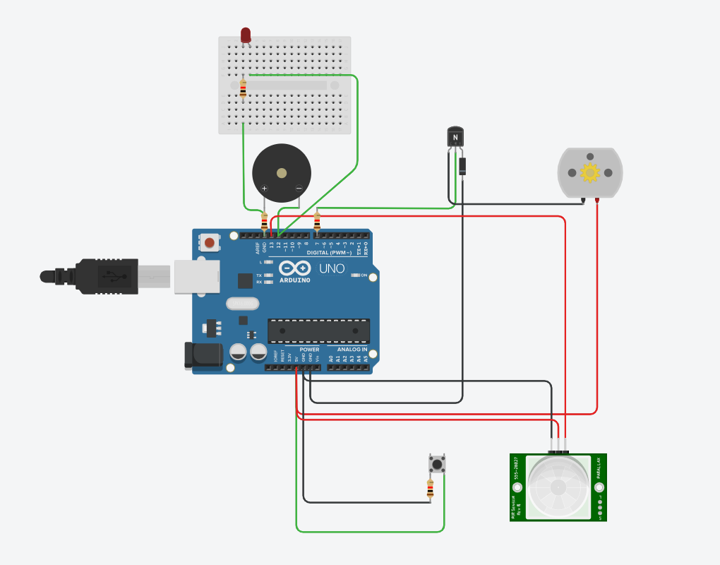

1. **ADRUINO CODE:**

int pirPin=13;

int pirStatus=0;

int piezoPin=12;

int buttonPin=6;

int buttonStatus=0;

int motorPin=7;

void setup()

{

pinMode(pirPin, INPUT);

pinMode(piezoPin,OUTPUT);

pinMode(motorPin,OUTPUT);

}

void loop()

{

pirStatus=digitalRead(pirPin);

if (pirStatus ==HIGH){

tone(piezoPin,5000);

} else {

noTone(piezoPin);

}

buttonStatus=digitalRead(buttonPin);

if (buttonStatus==HIGH){

digitalWrite(motorPin,HIGH);

} else {

digitalWrite(motorPin,LOW);

}

}

1. **GERBER FILE:**

